**Object model:**

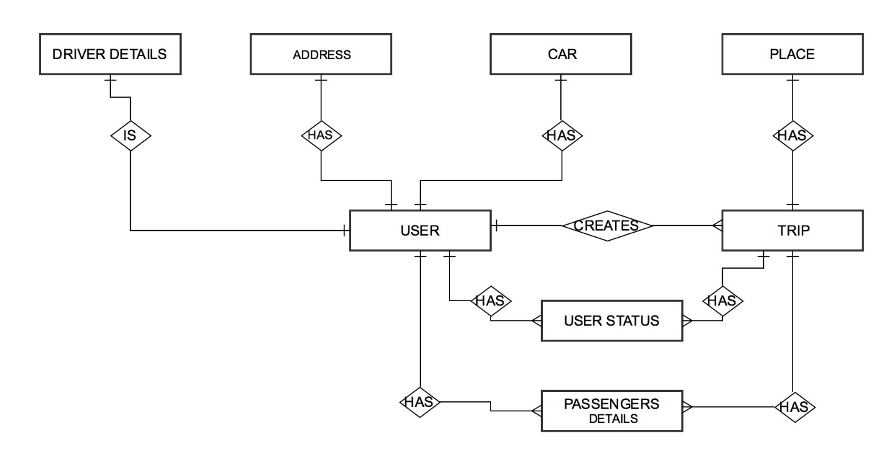

**Entities in the application are as follows:**

1. **User:** The user can share his ride or trip by means of carpooling. A user can be a passenger looking for a ride or a person who wish to carpool with other users or companions. A initiator of the trip will approve the request from other passengers who wishes to join.
2. **Driver details:** It will contain the details of the driver such as the license no, its validity etc.
3. **Car:** It contains the details of car owned by user. It has one to one or one to many mapping with user.
4. **Address:** It has the address details of each registered user in a website.
5. **Companion/Passenger details:** This entity lists the details of passengers sharing a ride.
6. **Trip:** It contains the details about a particular trip like its start location and its destination, its distance, cost of the trip etc.
7. **Place:** Will store all the locations which will be used by other entities.
8. **User status:** will contain the status of the request of a user for a particular trip.

**Roles in the application are as follows:**

1. Admin: the admin will be able to remove a user and monitor the entire application.
2. Guest User: The user can be a guest user who wishes to search a ride or want to know about the application.
3. Registered User: The user is made available to various privileges by getting itself registered. They can post a ride or can search for a new ride.

**Business Idea:**

The application provides a platform to users who wishes to reduce their travelling costs by carpooling their ride by posting a trip or joining a trip which is made available by the website on their wall. It helps to reduce gas consumption, traffic on the roads and eventually reduce CO2 emissions.